Progressive Approach to Building an AI Software Engineering Agent

- Executive Summary

Artificial Intelligence is increasingly becoming a practical component of modern software engineering. Rather than immediately attempting to build a complete AI-driven Software Development Lifecycle (AI-SDLC) platform, a progressive approach is recommended.

The proposed approach starts with a focused Software Engineer Agent capable of interacting with a real software repository, understanding development tasks, inspecting existing code, modifying source files, executing tests, analyzing failures, and iterating toward a validated solution.

The objective is to first validate the fundamental capabilities of an AI software engineering agent in a controlled environment. Once this capability is demonstrated and stabilized, the solution can progressively evolve toward specialized agents, controlled autonomy, orchestration, and ultimately an AI-assisted Software Development Lifecycle.

The approach can therefore be summarized as:

Start small → Validate → Improve → Industrialize → Expand → Orchestrate → Scale

- Context and Objective
  - Context
AI-assisted software development is evolving from simple code completion toward agents capable of performing complete engineering tasks.

A modern software engineering agent can potentially:
- Understand a development requirement
- Explore an existing codebase
- Identify relevant files and components
- Analyze existing implementation
- Propose changes
- Modify source code
- Execute commands
- Run tests
- Analyze test failures
- Correct implementation issues
- Re-run validation
- Produce a summary of the changes

This creates an opportunity to move from AI-assisted coding toward AI-assisted software engineering.

However, implementing the complete vision from the beginning would introduce significant technical and organizational complexity.
Therefore, the recommended strategy is to progressively build and validate the capabilities.
  - Objective
The objective is to build an internal AI Software Engineer Agent that can assist developers with real software engineering tasks while operating within controlled technical and security boundaries.
The initial objective is not to replace developers or automate the entire SDLC.
The first objective is to demonstrate that an AI agent can reliably perform a bounded development task on an existing repository.

The agents should be able to inspect the repository, understand the implementation, identify the required changes, modify the code, execute the relevant tests, analyze failures, and iterate until the task reaches a defined validation state.

- Target Vision

AI-Assisted Software Development Lifecycle
The long-term vision is an AI-assisted software development ecosystem where specialized AI agents support different stages of the Software Development Lifecycle.

The target lifecycle includes:
- Requirements Analysis
- Planning & Architecture
- Design
- Development
- Testing & QA
- Deployment & Release
- Maintenance & Continuous Improvement
Each stage can progressively be supported by specialized AI capabilities.
Target Agent Ecosystem
- Requirements / Analysis Agent
- Architecture Agent
- Software Engineer Agent
- Testing Agent
- Code Review / Quality Agent
- Documentation Agent
- Future specialized agents depending on business needs

These agents would eventually work together through an orchestration layer.

- Target Architecture

The target architecture can be organized into several logical layers.
  - User / Developer Layer
The developer provides:
- A development requirement
- A bug report
- A feature request
- A refactoring task
- Technical feedback
- Additional instructions
  - Orchestration Layer
At the target stage, an orchestration layer coordinates:
- Workflow execution
- Agent selection
- Context management
- Task state
- Tool execution
- Validation
- Human approval

The orchestrator is intentionally not part of the initial implementation.

It becomes relevant once multiple specialized agents and sufficiently complex workflows exist.
  - Specialized Agent Layer
The target architecture can contain specialized agents such as:

Requirements / Analysis Agent
Responsible for:
- Requirement analysis
- Ambiguity detection
- Functional decomposition
- Identification of constraints
Architecture Agent
Responsible for:
- Technical architecture
- Component identification
- API and integration analysis
- Technical design recommendations
Software Engineer Agent
Responsible for:
- Codebase exploration
- Implementation
- Refactoring
- Debugging
- Test execution
- Iterative correction
Testing Agent
Responsible for:
- Test generation
- Test execution
- Failure analysis
- Regression validation
Quality Agent
Responsible for:
- Static analysis
- Code quality
- Security findings
- Review support
Documentation Agent
Responsible for:
- Technical documentation
- API documentation
- Code documentation
- Change summaries

- Target Technical Architecture

The target architecture can be represented as:
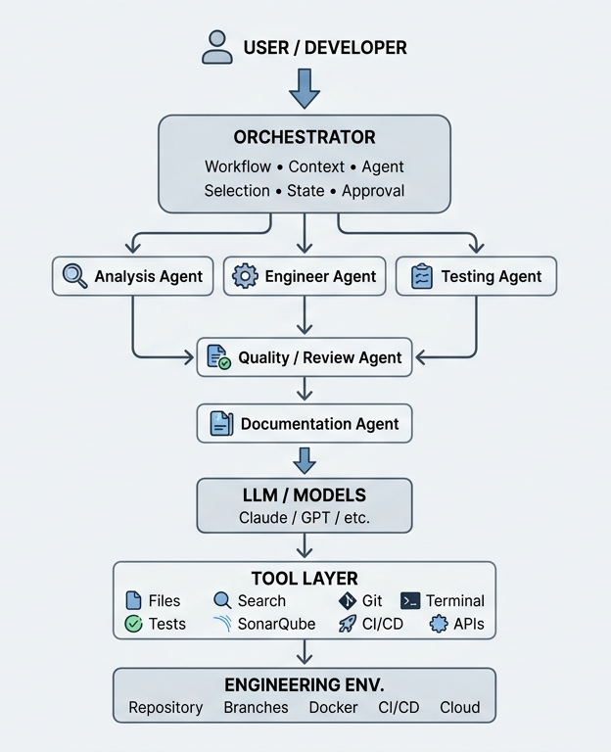

- Progressive Implementation Strategy

The complete target architecture should not be implemented immediately.
The recommended approach is to progressively increase the agent's capabilities.

Phase 1 — Foundation
Objective
Build the minimum technical foundation required for an AI agent to interact with a repository.

Components
- LLM connection
- Agent loop
- Repository workspace
- File access
- Code search
- Command execution
Initial tools
list_files
read_file
search_code
execute_command

Result
The agent can understand and explore a real codebase.

Phase 2 — Software Engineer Agent
The second phase introduces controlled code modification.
Capabilities
The agent should be able to:
- Understand the task
- Explore the repository
- Search for relevant implementation
- Read source files
- Determine required changes
- Modify source files
- Execute commands
- Run tests
Tools
list_files
read_file
search_code
write_file
execute_command

Result
A functional Software Engineer Agent capable of implementing bounded development tasks.

Phase 3 — Engineering Loop
The next step is to move beyond simple code generation.
The agent should be able to perform a complete engineering loop.

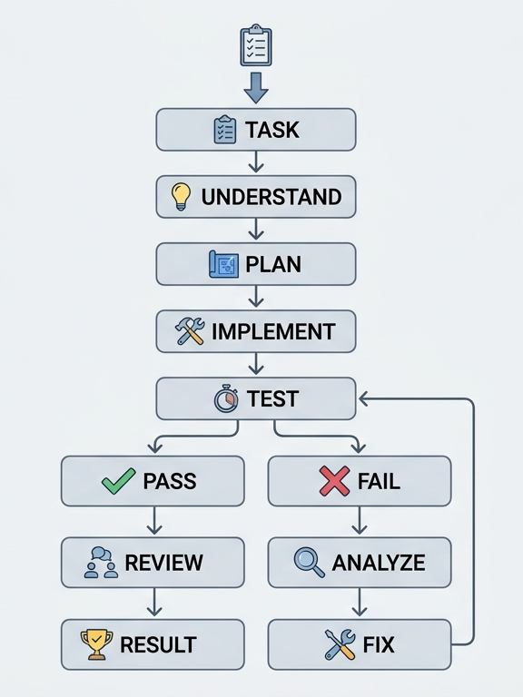
New capabilities
- Basic task planning
- Implementation
- Test execution
- Failure analysis
- Automatic correction
- Retesting
- Final result reporting

Result
The agent becomes capable of handling an engineering task through multiple iterations rather than generating code only once.

Phase 4 — Controlled Autonomy
Once the basic engineering loop is reliable, additional controls can be introduced.
Capabilities
- Git status
- Git diff
- Git branch creation
- Commit preparation
- Build validation
- Test validation
- Linting
- SonarQube analysis
- Docker isolation
- Human approval

Controlled workflow

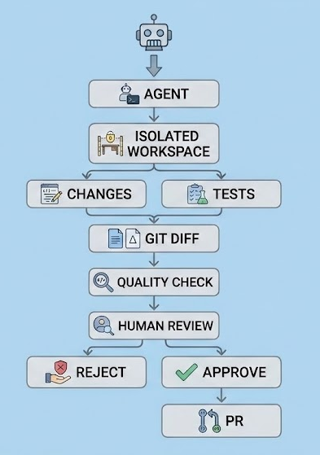

The agent should operate primarily through an isolated branch/workspace rather than directly modifying production environments.

Phase 5 — Specialized Agents
Once the Software Engineer Agent has demonstrated value, specialized agents can progressively be introduced.

Potential agents include:

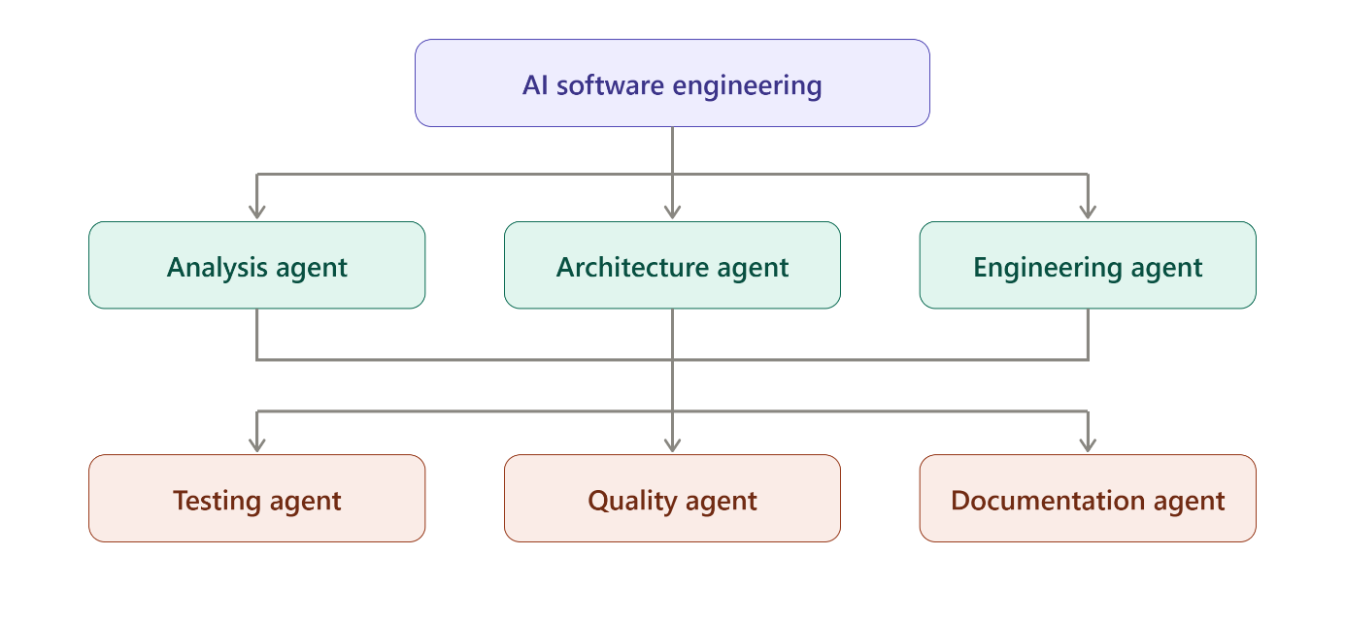
Each agent should have a clearly defined responsibility.

This avoids creating a large autonomous system before individual capabilities have been validated.

Phase 6 — Orchestration
Once multiple agents exist, an orchestration layer becomes valuable.

The orchestrator would determine:
- Which agent should execute a task
- In which order
- What context should be provided
- When validation should occur
- When another agent should be invoked
- When human approval is required
- When the workflow should stop

This stage represents the transition from a collection of AI capabilities to an AI-assisted engineering workflow.

Phase 7 — AI-Assisted SDLC

The final target is an AI-assisted SDLC ecosystem.
The system could support the lifecycle from requirements through maintenance.

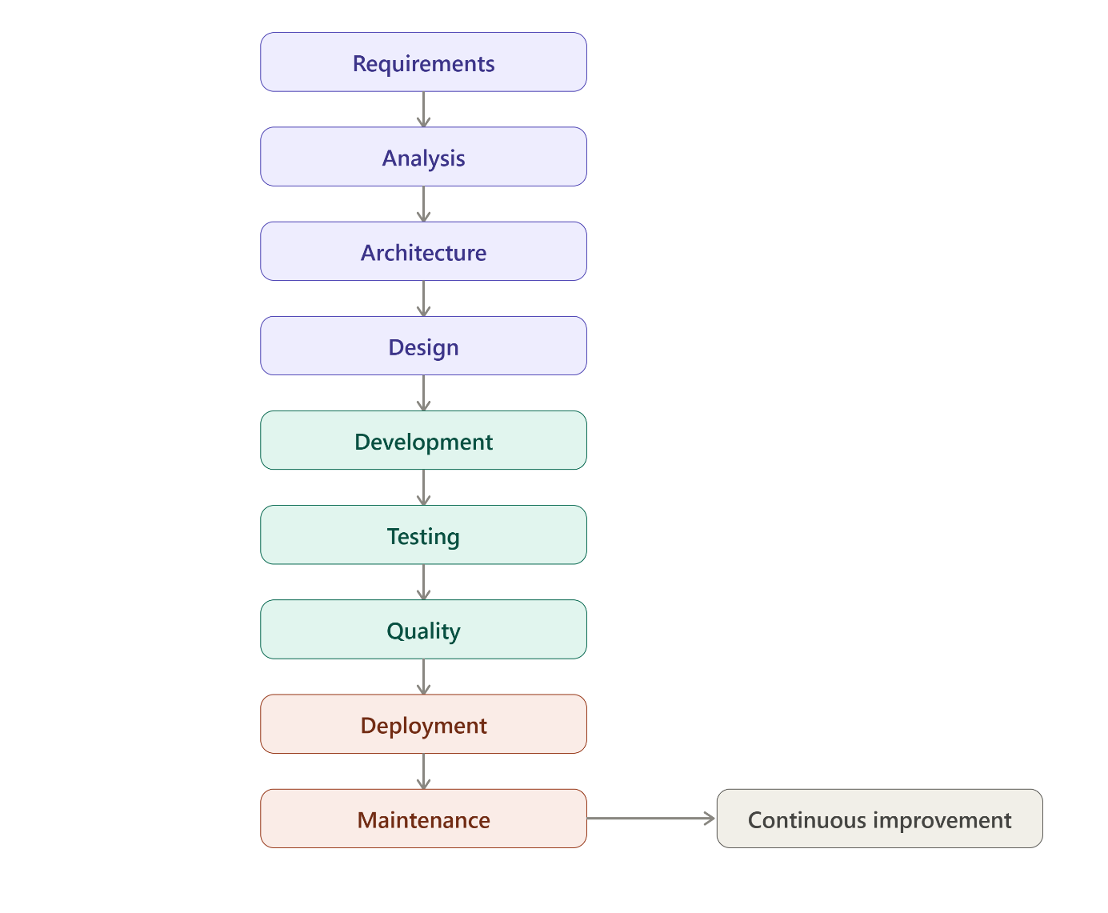
AI agents would support each stage while developers and technical stakeholders retain control over important decisions and approvals.

- Progressive Maturity Model

The overall evolution can be summarized as follows:

Stage | Capability | Main Objective
1. Foundation | LLM + tools + agent loop | Validate the technical foundation
2. Code Agent | Read / Search / Write / Execute | Implement development tasks
3. Engineering Agent | Plan / Implement / Test / Fix | Complete engineering loops
4. Controlled Autonomy | Git / Quality / Isolation / Approval | Operate safely on real projects
5. Specialized Agents | Analysis / Testing / Review / Documentation | Expand capabilities
6. Orchestration | Multi-agent workflows | Coordinate engineering activities
7. AI-Assisted SDLC | End-to-end capabilities | Support the complete lifecycle

- Proposed First Step

The immediate next step is to build a Software Engineer Agent POC.
Scope

The POC should:
- Accept a development task
- Connect to an LLM
- Inspect a real repository
- Search the codebase
- Read source files
- Modify source files
- Execute tests
- Analyze failures
- Attempt corrections
- Produce a final summary

First milestone

A successful first milestone would be:
The agent receives a real development task and independently produces a validated code change in an isolated repository workspace.

This provides a concrete foundation for evaluating the technology before expanding toward multiple agents and orchestration.

- Success Criteria for the Initial POC

The POC should be evaluated using real development tasks.

Example tasks:
- Add an API endpoint
- Add pagination
- Fix a bug
- Add validation
- Refactor a service
- Add unit tests
- Update an existing feature

For each task, evaluate:

Functional capability
Can the agent correctly implement the requested change?

Repository understanding
Can it identify the correct files and existing architecture?

Validation
Can it run and interpret tests?

Recovery
Can it analyze failures and attempt corrections?

Safety
Can it operate without directly affecting protected environments?

Human control
Can a developer review and approve the resulting changes?

